EXPERIMENT 07: BINARY SEARCH TREE
#include <iostream>
using namespace std;

struct Node {
int data;
Node *left, *right;
Node(int val) : data(val), left(NULL), right(NULL) {}
};

class BST {
public:
Node* insert(Node* root, int val) {
if (!root) return new Node(val);
if (val < root->data) root->left = insert(root->left, val);
else root->right = insert(root->right, val);
return root;
}

Node* deleteNode(Node* root, int val) {
if (!root) return NULL;
if (val < root->data) root->left = deleteNode(root->left, val);
else if (val > root->data) root->right = deleteNode(root->right, val);
else {
if (!root->left) return root->right;
else if (!root->right) return root->left;
Node* temp = minValue(root->right);
root->data = temp->data;
root->right = deleteNode(root->right, temp->data);
}
return root;
}

Node* minValue(Node* node) {
while (node && node->left) node = node->left;
return node;
}

void inorder(Node* root) {
if (!root) return;
inorder(root->left);
cout << root->data << " ";
inorder(root->right);
}

void preorder(Node* root) {
if (!root) return;
cout << root->data << " ";
preorder(root->left);
preorder(root->right);
}

void postorder(Node* root) {
if (!root) return;
postorder(root->left);
postorder(root->right);
cout << root->data << " ";
}

void display(Node* root, int space = 0, int gap = 5) {
if (!root) return;
space += gap;
display(root->right, space);
cout << endl;
for (int i = gap; i < space; i++) cout << " ";
cout << root->data << "\n";
display(root->left, space);
}
};

int main() {
BST tree;
Node* root = NULL;
int choice, val;

do {
cout << "\n1. Insert\n2. Delete\n3. Inorder\n4. Preorder\n5. Postorder\n6. Display Tree\n7. Exit\nEnter choice: ";
cin >> choice;

switch (choice) {
case 1:
cout << "Enter value to insert: ";
cin >> val;
root = tree.insert(root, val);
break;
case 2:
cout << "Enter value to delete: ";
cin >> val;
root = tree.deleteNode(root, val);
break;
case 3:
cout << "Inorder: ";
tree.inorder(root);
cout << endl;
break;
case 4:
cout << "Preorder: ";
tree.preorder(root);
cout << endl;
break;
case 5:
cout << "Postorder: ";
tree.postorder(root);
cout << endl;
break;
case 6:
cout << "Tree structure:\n";
tree.display(root);
break;
case 7:
cout << "Exiting...\n";
break;
default:
cout << "Invalid choice!\n";
}
} while (choice != 7);

return 0;
}
OUTPUT:
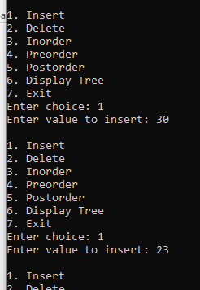
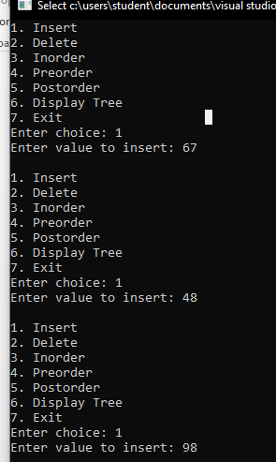
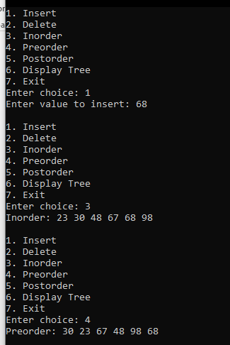
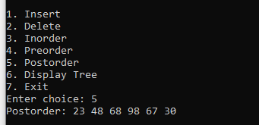
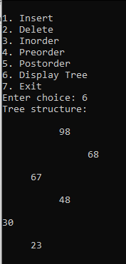

EXPERIMENT 08: SORTING TECHNIQUES (INSERTION AND HEAP SORT)
(Insertion sort)
#include <iostream>
void insertionSort(int arr[], int n) {
for (int i = 1; i < n; ++i) {
int key = arr[i];
int j = i - 1;
while (j >= 0 && arr[j] > key) {
arr[j + 1] = arr[j];
j = j - 1;
}
arr[j + 1] = key;
}
}
void printArray(int arr[], int n) {
for (int i = 0; i < n; ++i) {
std::cout << arr[i] << " ";
}
std::cout << std::endl;
}
int main() {
int arr[] = { 3,9,24,18,28,16,21,5 };
int n = sizeof(arr) / sizeof(arr[0]);
std::cout << "Original array: ";
printArray(arr, n);
insertionSort(arr, n);
std::cout << "Sorted array: ";
printArray(arr, n);
return 0;
}
OUTPUT:
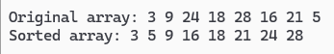

(Heap sort)
#include <iostream>
#include <vector>
using namespace std;
void heapify(vector<int>& arr, int n, int i) {
int largest = i;
int left = 2 * i + 1;
int right = 2 * i + 2;
if (left < n && arr[left] > arr[largest])
largest = left;
if (right < n && arr[right] > arr[largest])
largest = right;
if (largest != i) {
swap(arr[i], arr[largest]);
heapify(arr, n, largest);
}
}
void heapSort(vector<int>& arr) {
int n = arr.size();

for (int i = n / 2 - 1; i >= 0; i--)
heapify(arr, n, i);

for (int i = n - 1; i > 0; i--) {
swap(arr[0], arr[i]);
heapify(arr, i, 0);
}
}
int main() {
int n;
cout << "Enter number of elements: ";
cin >> n;
vector<int> arr(n);
cout << "Enter " << n << " numbers:\n";
for (int i = 0; i < n; i++)
cin >> arr[i];
heapSort(arr);
cout << "Sorted array:\n";
for (int num : arr)
cout << num << " ";
cout << endl;
return 0;
}
OUTPUT:
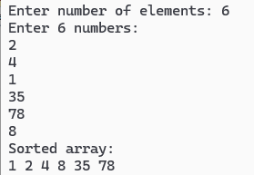
EXPERIMENT 09: SORTING TECHNIQUES (MERGE AND QUICK SORT)
(Merge sort)
#include <iostream>
using namespace std;
void merge(int arr[], int l, int m, int r) {
int n1 = m - l + 1;
int n2 = r - m;
int L[50], R[50];
for (int i = 0; i < n1; i++)
L[i] = arr[l + i];
for (int j = 0; j < n2; j++)
R[j] = arr[m + 1 + j];
int i = 0, j = 0, k = l;
while (i < n1 && j < n2)
arr[k++] = (L[i] <= R[j]) ? L[i++] : R[j++];

while (i < n1) arr[k++] = L[i++];
while (j < n2) arr[k++] = R[j++];
}
void mergeSort(int arr[], int l, int r) {
if (l >= r) return;
int m = (l + r) / 2;
mergeSort(arr, l, m);
mergeSort(arr, m + 1, r);
merge(arr, l, m, r);
}
int main() {
int arr[50], n;
cout << "Enter number of elements (max 50): ";
cin >> n;
cout << "Enter " << n << " numbers:\n";
for (int i = 0; i < n; i++)
cin >> arr[i];
mergeSort(arr, 0, n - 1);
cout << "Sorted array:\n";
for (int i = 0; i < n; i++)
cout << arr[i] << " ";
cout << endl;
return 0;
}
OUTPUT:
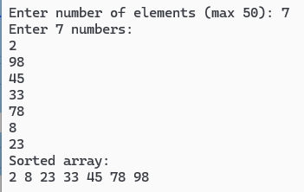

(Quick sort)
#include <iostream>
using namespace std;
void quickSort(int arr[], int left, int right) {
if (left >= right) return;
int pivot = arr[right];
int i = left, j = right;
while (i < j) {
while (arr[i] < pivot) i++;
while (arr[j] > pivot) j--;
if (i <= j) {
swap(arr[i], arr[j]);
i++; j--;
}
}
quickSort(arr, left, j);
quickSort(arr, i, right);
}
int main() {
int arr[] = { 5, 2, 9, 1, 5, 6 };
int n = sizeof(arr) / sizeof(arr[0]);
quickSort(arr, 0, n - 1);
for (int i = 0; i < n; i++)
cout << arr[i] << " ";
cout << endl;
return 0;
}
OUTPUT:
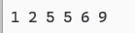

EXPERIMENT 10: SEARCH TECHNIQUES LINEAR AND BINARY SEARCH)
(Linear search)
#include <iostream>
#include <vector>
using namespace std;
int linearSearch(const vector<int>& arr, int key) {
for (int i = 0; i < arr.size(); i++) {
if (arr[i] == key)
return i;
}
return -1;
}
int main() {
int n, key;
cout << "Enter number of elements: ";
cin >> n;
vector<int> arr(n);
cout << "Enter " << n << " numbers:\n";
for (int i = 0; i < n; i++)
cin >> arr[i];
cout << "Enter number to search: ";
cin >> key;
int result = linearSearch(arr, key);
if (result != -1)
cout << "Found at index " << result << endl;
else
cout << "Not found in the array.\n";
return 0;
}
OUTPUT:
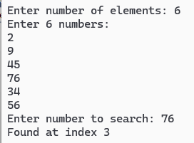
(Binary search)
#include <iostream>
#include <vector>
#include <algorithm>
using namespace std;
int binarySearch(const vector<int>& arr, int key) {
int left = 0, right = arr.size() - 1;
while (left <= right) {
int mid = left + (right - left) / 2;
if (arr[mid] == key)
return mid;
else if (arr[mid] < key)
left = mid + 1;
else
right = mid - 1;
}
return -1;
}
int main() {
int n, key;
cout << "Enter number of elements: ";
cin >> n;
vector<int> arr(n);
cout << "Enter " << n << " sorted numbers:\n";
for (int i = 0; i < n; i++)
cin >> arr[i];
cout << "Enter number to search: ";
cin >> key;
sort(arr.begin(), arr.end());
int result = binarySearch(arr, key);
if (result != -1)
cout << "Found at index " << result << endl;
else
cout << "Not found in the array.\n";
return 0;
}
OUTPUT:
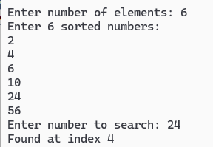

EXPERIMENT 10: GRAPHS TRAVERSAL
(Breadth-First Search (BFS))
#include <iostream>
#include <vector>
#include <queue>
using namespace std;
void bfs(int start, const vector<vector<int>>& graph, vector<bool>& visited) {
queue<int> q;
visited[start] = true;
q.push(start);
while (!q.empty()) {
int node = q.front();
q.pop();
cout << node << " ";
for (int neighbor : graph[node]) {
if (!visited[neighbor]) {
visited[neighbor] = true;
q.push(neighbor);
}
}
}
}
int main() {
int n = 6;
vector<vector<int>> graph(n);
graph[0] = { 1, 2 };
graph[1] = { 0, 3, 4 };
graph[2] = { 0, 4 };
graph[3] = { 1, 5 };
graph[4] = { 1, 2, 5 };
graph[5] = { 3, 4 };
vector<bool> visited(n, false);
cout << "BFS starting from node 0: ";
bfs(0, graph, visited);
return 0;
}
OUTPUT:
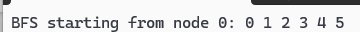

(Depth-First Search (BFS))
#include <iostream>
#include <vector>

using namespace std;

void dfs(int node, const vector<vector<int>>& graph, vector<bool>& visited) {
visited[node] = true;
cout << node << " ";

for (int neighbor : graph[node]) {
if (!visited[neighbor]) {
dfs(neighbor, graph, visited);
}
}
}
int main() {
int n = 6; // Number of nodes
vector<vector<int>> graph(n);
graph[0] = {1, 2};
graph[1] = {0, 3, 4};
graph[2] = {0, 4};
graph[3] = {1, 5};
graph[4] = {1, 2, 5};
graph[5] = {3, 4};
vector<bool> visited(n, false);
cout << "DFS starting from node 0: ";
dfs(0, graph, visited);
return 0;
}
OUTPUT:

